**Final Paper**

Paul Polsinelli

Information Technology, Arizona State University

IFT 472: Managing the Cloud

Professor Neff

Oct 9th, 2020

**Final Paper**

IT infrastructure can be decreased and optimized through cloud migration to the AWS platform. This is done through economies of scale and payment for precise usage of infrastructure and services. One of the key ways in which this happens is by taking advantage of AWS’s elastic cloud capabilities. Using scheduled scaling from known traffic patterns, EC2 auto scales compute instances in several ways; Fleet Management monitors the health of instances and adds or deletes them as needed, Auto Scaling Groups sets preconfigured criteria to aid in such; and Elastic Load Balancing directs traffic, scales, and performs health checks while using either application, network, or classic load balancing optimized for different case uses (New Relic, n.d.). Another key way to leverage the platform is by carefully considering the pricing models for compute and storage. Organizations can mix and match models such as On-Demand Instances that can be paid by the hour or second, Spot Instances which have pre-defined price points for periods of time and adjusts with supply and demand, Reserved Instances are good if there is a well understood and predictable usage, and Dedicated Hosts, which are like having your own physical server, but in the cloud (New Relic, n.d.).

In addition to the specific services AWS offers, having the right strategies and methodologies specific to AWS can help keep costs low. Some examples would be using a cost dashboard to track costs granularly, monitoring cost trends, comparing cost vs. utilization, examining cost ratios for optimization insights, utilizing tagging strategies for keeping accounts in order, and having a Reserved Instances Strategy to be prepared for expected and unexpected fluctuations in service needs (Charoenrath, 2020).

Generally speaking, there are several areas where savings can be realized by migration. Shutting down the onsite data center will save on electricity, manpower, equipment, data storage, and space costs (Violino, 2020). Telecom costs can be significantly downsized as well without the in-house need. Processes can potentially be streamlined for savings, including infrastructure services being handled by fewer vendors. And e-commerce and customer analytics costs can be cut through scalability.

ASU’s migration will follow AWS’s migration process, which will consist of three phases; Assess, Mobilize, and Migrate and Modernize (AWS, 2020a). Each phase is aided by various AWS tools and services to make the process as smooth as possible. The process is designed in such a way that the phases are not discreet, but rather, they accelerate the migration process as they progress. Through their third-party migration tooling ecosystem, they also provide automation and intelligent recommendations based on AWS machine learning.

The first phase is Assess. This includes identifying desired business outcomes and development of a business case. AWS has three tools to offer to aid in this phase. The first is the Migration Evaluator. Using data ASU provides, they will make recommendations on compute size and costs, software, and TCO reduction while helping to build the business case (AWS, 2020a). Then there is the Cloud Adoption Readiness Tool (CART). CART gathers information through a survey and then assesses migration readiness through business, people, process, platform, operations, and security perspectives. The third tool of this phase is the AWS Migration Hub, which is the single point hub through which the overall migration process and tools are managed.

The second phase is Mobilize. The strategy in this phase revolves around seven common migration strategies; relocate, rehost, replatform, refactor, repurchase, retire, or retain; and deciding if and where to apply each (AWS, 2020a). There are five tools and services associated with this phase. We’ll start with AWS Application Discovery Services whose purpose is simply to gather and organize server data and present it in a way to provide better understanding of workloads. Second on the list is Migration Partner Solutions. This service pairs migrating organizations with certified partners that can aid in the process. After that we have AWS Management and Governance services. Simply put, this is the standard IT resource lifecycle management system that AWS provides to optimize IT services. Following that is the AWS Landing Zone solution which helps set up the environment in line with AWS best security practices. And lastly in this phase is AWS Control Tower. It provides dashboards to monitor and control migration details.

The third phase is Migrate and Modernize. This is the meat of the process, where migration actually happens. AWS offers a powerful suite of tools and services here. First are the services for migrating servers, databases, and applications. We’ll start with CloudEndure Migration, which continually replicates data from source machines and stages the migration in AWS for minimum downtime (AWS, 2020a). AWS Server Migration Service migrates virtual workloads from virtual servers while VMware Cloud on AWS migrates VMware based applications. For both homogenous and heterogenous database migrations we use AWS Database Migration Service. The last service in this category is AWS Marketplace. It essentially provides third party SaaS to replace in-perpetuity license fees.

The second category of services and tools in this phase is for data transfer. We’ll begin with AWS DataSync. This service copies, rapidly transfers, and then verifies NFS file system data to S3, EFS, or FSx (AWS, 2020a). AWS Transfer Family manages the file transfer process into and out of S3 over SFTP, FTPS, and FTP using Route 53 routing service. An optional service is AWS Snow family, which is a small suite of services itself, consisting of AWS Snowcone, AWS Snowball, and AWS Snowmobile. This solution provides rugged physical devices and trucks for migrating on-premise data off site if and when internet migration is not an option (AWS, 2020b).

Once Data has been transferred, there are two last services that could be taken advantage of; AWS Managed Services and AWS Service Catalog (AWS, 2020a). The basic difference conceptually with these two offerings are whether one wishes to put more IT management in the hands of AWS or keep more control in house, respectively.

Below are the rough cost estimates of using AWS services for use in comparing to in-house costs at ASU.

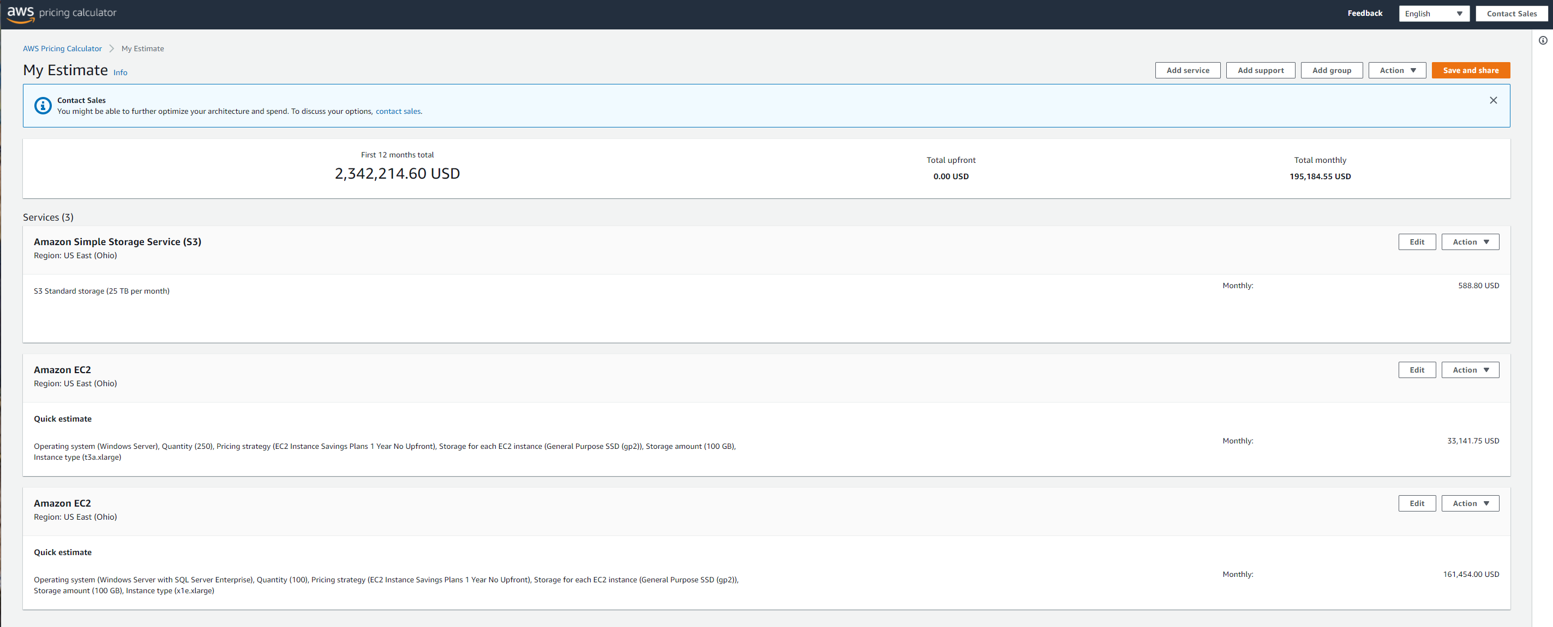

References

New Relic. (n.d.). *AWS Cost Optimization*. Retrieved October 5, 2020, from <https://newrelic.com/solutions/aws/aws-cost-optimization>

Violino, B. (2020, March 16). *Where to look for cost savings in the cloud*. InfoWorld. https://www.infoworld.com/article/3532288/where-to-look-for-cost-savings-in-the-cloud.html

Charoenrath, M. (2020, May 14). *The 6 Best Ways to Reduce Costs on AWS*. Onica. https://onica.com/blog/managed-services/best-ways-to-reduce-costs-in-aws/

AWS. (2020a). *How to Migrate - Amazon Web Services*. Amazon Web Services, Inc. https://aws.amazon.com/cloud-migration/how-to-migrate/

AWS. (2020b). *Explore the new AWS Snowcone with Bill Vass and Jeff Barr (2:46)*. Amazon Web Services, Inc. https://aws.amazon.com/snow/